FOOD DELIVERY TIME ANALYSIS

Student Details

Name: Dharshini S

Course: B.Sc. Computer Science with Data Science

Institution: SDNB Vaishnav College For Women

Internship: Data Analytics Internship

Project Title: Food Delivery Time Analysis

Tools Used: Python, Pandas, NumPy, Matplotlib, Seaborn, SciPy, VS Code

FOOD DELIVERY TIME ANALYSIS USING DATA ANALYTICS

ABSTRACT
Food delivery services play a major role in modern urban lifestyles. However, delivery delays can negatively affect customer satisfaction and operational efficiency. This project aims to analyze various factors affecting food delivery time using data analytics techniques. The analysis was performed using Python libraries such as Pandas, Matplotlib, Seaborn, and Scikit-learn.
The project focuses on identifying how factors such as traffic level, weather condition, delivery distance, vehicle type, preparation time, and time of day influence delivery duration. Statistical analysis, visualization techniques, correlation analysis, and hypothesis testing were used to extract meaningful insights from the dataset.
The findings of this project help understand the major causes of delivery delays and demonstrate how data analytics can support business decision-making and operational improvements.

1. INTRODUCTION
Food delivery platforms have become an important part of daily life. Customers expect fast and reliable deliveries, but several real-world conditions can affect delivery performance. Delays in delivery may occur due to traffic congestion, long travel distance, weather conditions, restaurant preparation delays, and other operational challenges.
This project analyzes delivery data to identify the key factors responsible for delivery delays. Using data analytics techniques, the project aims to transform raw data into meaningful insights that can help businesses improve delivery efficiency.
The project also demonstrates the practical use of statistical analysis, data visualization, and hypothesis testing in solving business problems using data.

2. OBJECTIVE OF THE PROJECT
The main objectives of this project are:
- To analyze food delivery data using Python.
- To identify factors affecting delivery delays.
- To perform exploratory data analysis (EDA).
- To visualize delivery patterns using graphs.
- To study relationships between variables.
- To apply hypothesis testing to validate statistical significance.
- To generate business insights from the analysis.

3. PROBLEM STATEMENT
Food delivery companies often face delivery delays due to multiple operational and environmental factors. These delays can reduce customer satisfaction and increase operational costs.
The problem addressed in this project is:
“To identify the major factors affecting food delivery time and analyze their impact using data analytics techniques.”

4. TOOLS AND TECHNOLOGIES USED
The following tools and technologies were used in this project:

Programming Language
- Python

Development Environment
- VS Code
- Jupyter Notebook

Python Libraries
- Pandas
- NumPy
- Matplotlib
- Seaborn
- Scikit-learn
- SciPy

5. DATASET DESCRIPTION
Dataset Source
The dataset used in this project was obtained from Kaggle and contains information related to food delivery operations, including delivery distance, weather conditions, traffic levels, vehicle type, preparation time, courier experience, and delivery duration. The dataset was used solely for educational and analytical purposes as part of this internship project.
Data Set Name:
Food Delivery Time Prediction 🛵

Kaggle
https://www.kaggle.com › datasets › denkuznetz › food...
"
Food Delivery Time Prediction 🛵

Column Name | Description
Order_ID | Unique order identification
Distance_km | Delivery distance in kilometers
Weather | Weather condition during delivery
Traffic_Level | Traffic condition during delivery
Time_of_Day | Delivery time period
Vehicle_Type | Type of delivery vehicle
Preparation_Time_min | Food preparation time
Courier_Experience_yrs | Courier experience in years
Delivery_Time_min | Total delivery time in minutes

6. DATA PREPROCESSING
Data preprocessing is an important step before analysis. The dataset was cleaned and prepared using the following methods:

6.1 Checking Duplicate Values
Duplicate rows were checked using:
df.duplicated().sum()
No significant duplicate values were found in the dataset.

6.2 Checking Missing Values
Missing values were identified using:
df.isnull().sum()
Some columns contained missing values such as:
- Weather
- Traffic_Level
- Time_of_Day
- Courier_Experience_yrs

6.3 Handling Missing Values
Missing values were handled using:
- Mode imputation for categorical columns
- Mean imputation for numerical columns
This ensured the dataset became complete and suitable for analysis.
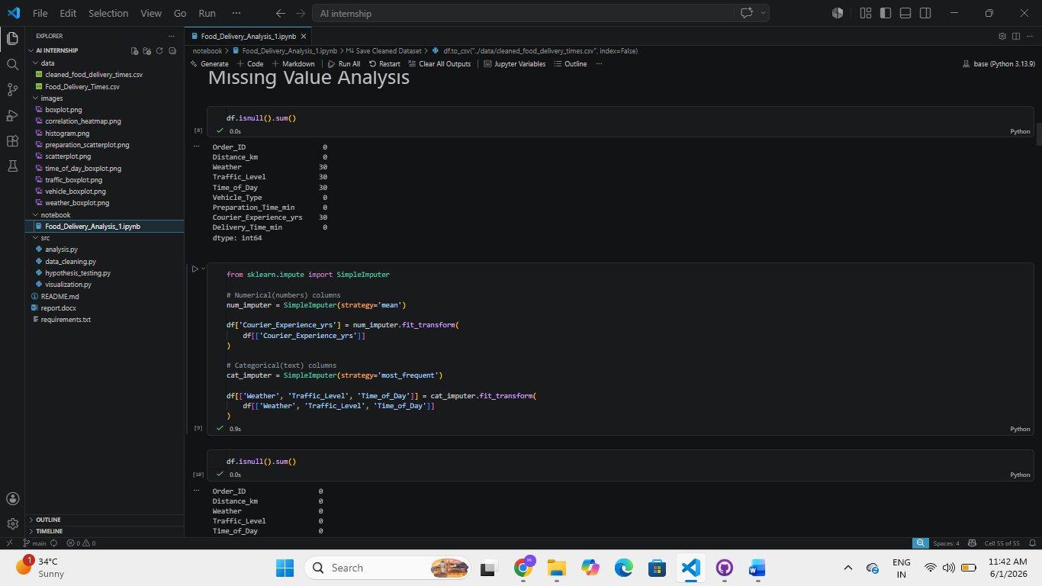

7. EXPLORATORY DATA ANALYSIS (EDA)
Exploratory Data Analysis was performed to understand the behavior and distribution of delivery data.

7.1 Statistical Analysis
Basic statistical measures were calculated for the delivery time column, including:
- Mean
- Median
- Mode
- Standard Deviation
- Variance
- Quartiles

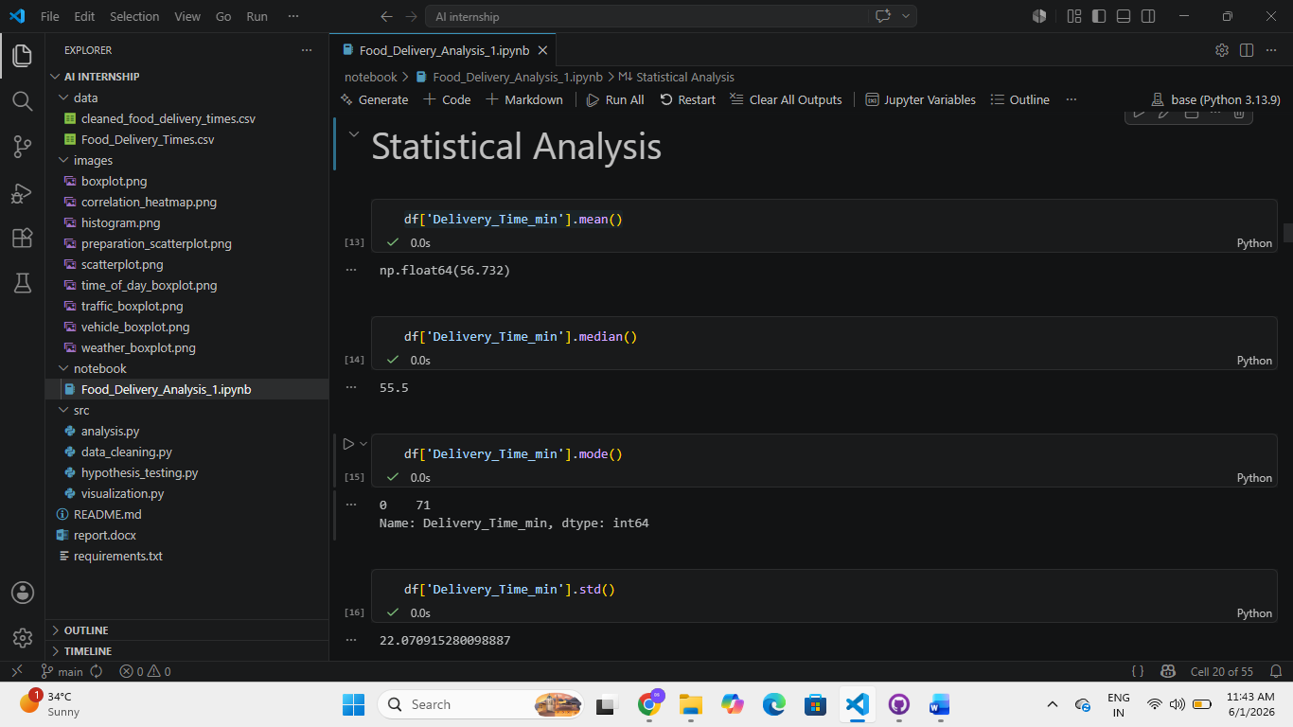
These statistics helped understand the overall delivery performance and variability.

The average delivery time was 56.73 minutes, while the median delivery time was 55.5 minutes, indicating a relatively balanced distribution. The most frequent delivery time observed was 71 minutes. The standard deviation of 22.07 minutes suggests moderate variability in delivery performance. Quartile analysis showed that 25% of deliveries were completed within 41 minutes, 50% within 55.5 minutes, and 75% within 71 minutes. Overall, the statistical analysis indicates that most deliveries were completed within a reasonable time range, although some variation exists due to operational and environmental factors.

7.2 Histogram Analysis
A histogram was created to analyze the distribution of delivery times.
Observation:
- Most deliveries were concentrated within a specific time range.
- Some deliveries showed unusually high delays.
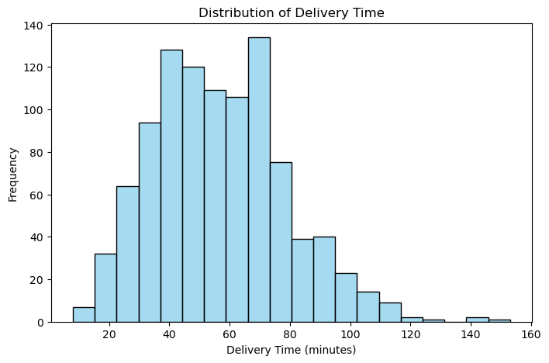

7.3 Boxplot Analysis
Boxplots were used to identify:
- Median delivery time
- Spread of data
- Outliers
The boxplots helped detect unusually delayed deliveries.

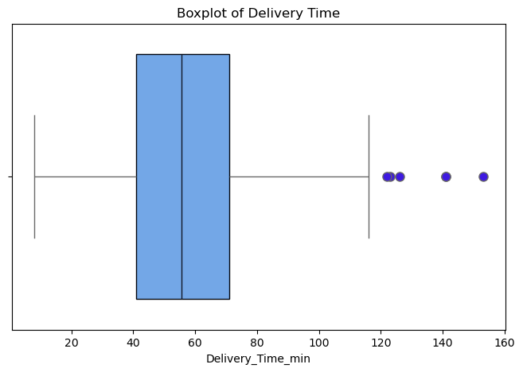

7.4 Scatterplot Analysis
A scatterplot was created between:
- Distance_km
- Delivery_Time_min
Observation:
- Delivery time generally increased as delivery distance increased.
- A positive relationship existed between distance and delivery duration.
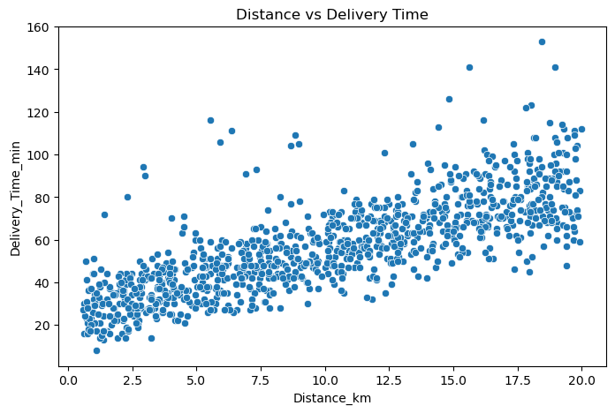

7.5 Correlation Analysis
Correlation analysis was performed to identify relationships between numerical variables.
A heatmap was created to visualize correlation values.
Observation:
- Distance and preparation time showed strong positive relationships with delivery time.
- Courier experience showed slight negative relationship with delivery duration.

8. FACTOR-WISE ANALYSIS
Several factors were analyzed individually against delivery time.

8.1 Weather vs Delivery Time
A boxplot was used to compare delivery times across weather conditions.
Observation:
- Snowy and rainy conditions generally showed higher delivery times.
- Weather conditions contributed to delivery delays.
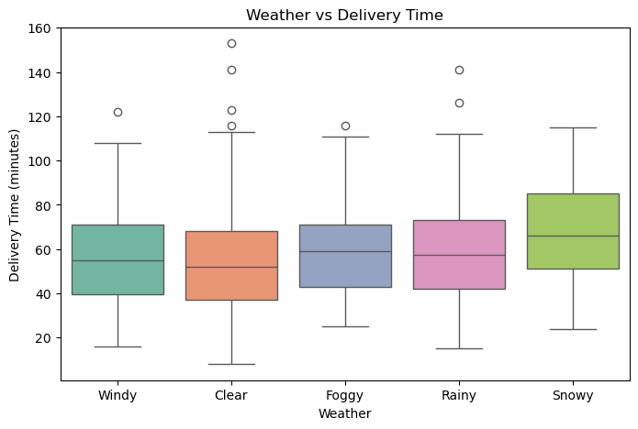

8.2 Traffic Level vs Delivery Time
Traffic levels were compared using boxplots.
Observation:
- High traffic conditions showed significantly higher delivery times.
- Traffic congestion strongly affected delivery performance.
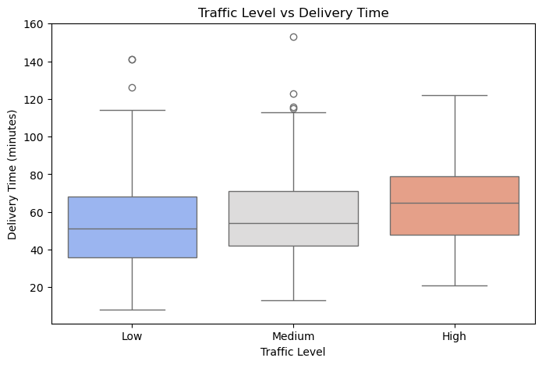

8.3 Vehicle Type vs Delivery Time
Delivery times were compared across different vehicle types.
Observation:
- Vehicle type showed moderate variation in delivery performance.
- Cars showed slightly higher delivery times compared to scooters and bikes.
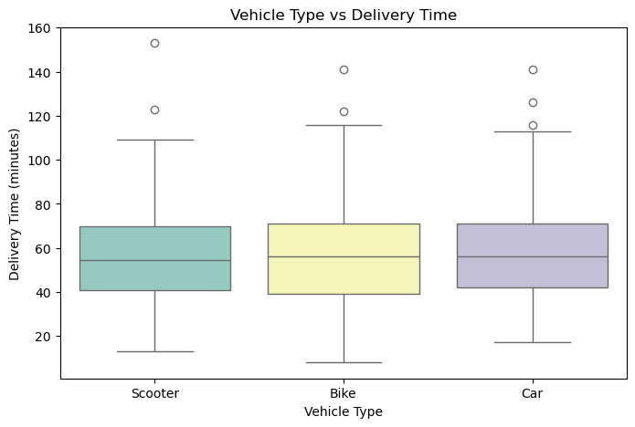

8.4 Time of Day vs Delivery Time
Delivery times were analyzed based on time periods.
Observation:
- Morning and evening periods showed slightly higher delays.
- Peak traffic hours may contribute to longer delivery durations.
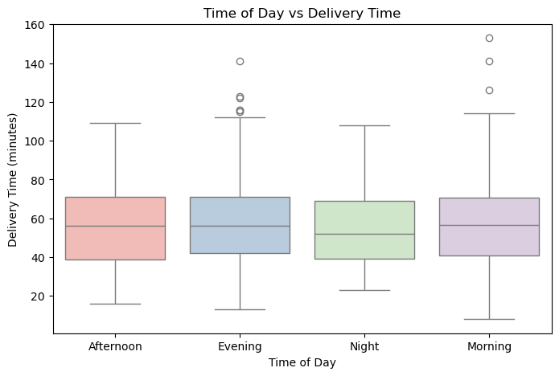

9. HYPOTHESIS TESTING
Hypothesis testing was performed to statistically verify whether traffic level significantly affects delivery time.

9.1 Null Hypothesis (H₀)
Traffic level does not affect delivery time.

9.2 Alternative Hypothesis (H₁)
Traffic level affects delivery time.

9.3 ANOVA Test
ANOVA testing was performed using SciPy.
P-value = 3.87e-09
P-value < 0.05
The obtained p-value was less than 0.05.
Observation:
- The null hypothesis was rejected.
- Traffic level significantly affects delivery time.

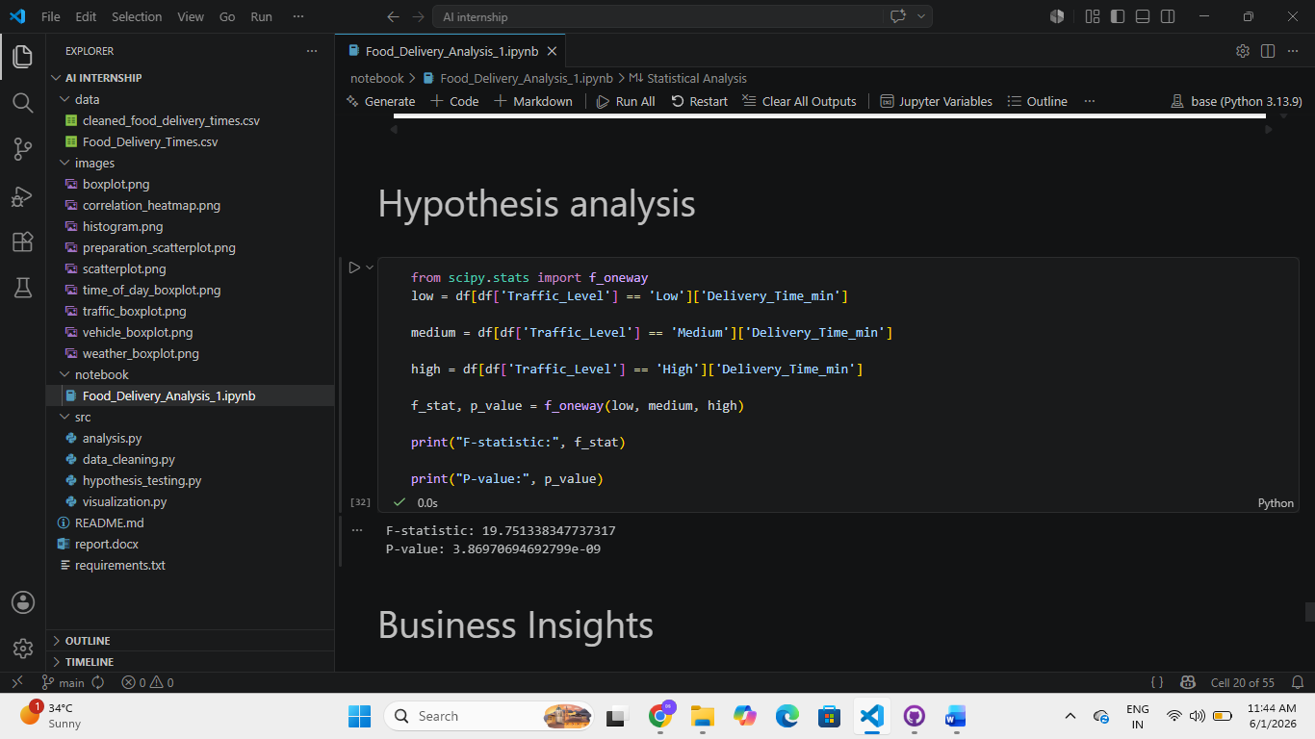

10. KEY INSIGHTS
The major insights obtained from the analysis are:
- Delivery time increases as delivery distance increases.
- High traffic conditions significantly increase delivery delays.
- Rainy and snowy weather conditions contribute to longer delivery times.
- Vehicle type has moderate impact on delivery performance.
- Morning and evening deliveries show slightly higher delays.
- Traffic level and delivery distance are major contributors to delivery delay.

11. BUSINESS RECOMMENDATIONS
Based on the analysis, the following recommendations can help improve delivery efficiency:
- Use route optimization during high traffic periods.
- Assign more delivery agents during peak hours.
- Improve delivery planning during bad weather conditions.
- Use nearby delivery hubs to reduce travel distance.
- Monitor restaurant preparation times to reduce waiting delays.

12. CONCLUSION
This project successfully analyzed various factors affecting food delivery time using data analytics techniques. The analysis demonstrated that delivery distance, traffic level, and weather conditions are major contributors to delivery delays.
Data visualization, correlation analysis, and hypothesis testing helped identify important patterns and relationships within the dataset. The project highlights how data analytics can support business decision-making and operational improvements in delivery services.
Overall, this project provided practical experience in data preprocessing, exploratory data analysis, statistical analysis, visualization, and business insight generation using Python.

13. FUTURE ENHANCEMENTS
Future improvements for this project may include:
- Applying machine learning models for delivery time prediction.
- Using real-time GPS and traffic data.
- Developing an interactive dashboard using Power BI or Tableau.
- Implementing AI-based route optimization systems.

14. REFERENCES
- Kaggle Dataset: Food Delivery Time Prediction Dataset
- Python Documentation
- Pandas Documentation
- Seaborn Documentation
- Scikit-learn Documentation
- SciPy Documentation

